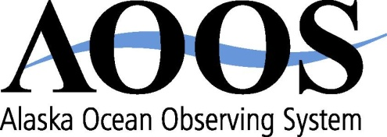
1007 W. Third Avenue, Suite 100
Anchorage, AK 99501
907.644.6703 – phone
907.644.6780 – fax
www.aoos.org

AOOS Executive Committee Meeting
Draft Summary prepared by Molly McCammon
May 24, 2012

Attending in Anchorage: Molly McCammon (AOOS staff), Darcy Dugan (AOOS staff for part of meeting) and Amy Holman (Treasurer)
Attending by phone: Ed Page (Chair), Ed Fogels (Vice Chair) and Glenn Sheehan (Secretary). Absent was Tara Jones (ex officio)

1. New grants received
AOOS Executive Director McCammon apprised the Executive Committee of the receipt by AOOS of four new grants that required Board approval to accept funding.
- North Pacific Research Board – contract to provide data management services for the Gulf of Alaska Integrated Ecosystem Research Project. $500k. 3 years.
- University of Alaska Fairbanks – contract to provide data management services for the RUSALCA project. $150k. 1 year.
- Western Alaska Landscape Conservation Cooperative – contract to support deployment of wave buoy in Bering Sea. $35k for 2 years.
- University of Maryland – subaward for AOOS staff to participate in Arctic data synthesis project funded by North Pacific Research Board. $35k. 2 years
Motion to approve acceptance of funds by Ed Fogels. Second by Ed Page. Passed unanimously.

2. Discussion about fall board member and recruitment of additional board members.
The Executive Committee does not consider recruitment of additional board members a pressing issue, but did ask that the issue be discussed at the fall board meeting. The committee also asked that the board meeting be devoted primarily to strategic planning for future years.

3. McCammon annual evaluation

McCammon briefed the committee on the 2011 performance objectives and accomplishments (see attached). The committee met in executive session to discuss the ED’s performance. Chairman Ed Page reported that the consensus of the committee is that McCammon is continuing to do an outstanding job. The recommendation is to “stay the course.” The committee also recommended that McCammon retain the leave deleted from her account this year that was in excess of her leave bank (approx 114 hours) per policy, on condition that it be used by the end of the calendar year (December 31, 2012). Per the terms of her employment contract, McCammon will receive an automatic increase retroactive to April 1 2012 based on the Anchorage Consumer Price Index.

4. Proposed 2012 ED Performance Objectives

McCammon presented a draft of performance objectives for 2012. The committee discussed these and made some modifications. The final version is attached.

The Committee adjourned at 4:45 pm.

