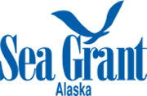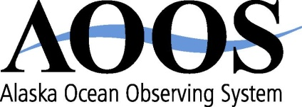

**ALASKA MARINE POLICY FORUM**

Summary of September 29, 2010 call

Hosted by Molly McCammon

Summary prepared by Molly McCammon, [mccammon@aoos.org](mailto:mccammon@aoos.org)

***Alaska Marine Policy Forum: A bimonthly teleconference for Alaskans to network and share information about marine policy, budgets and legislation at state, national and international levels, sponsored by Alaska Ocean Observing System and Alaska Sea Grant.***

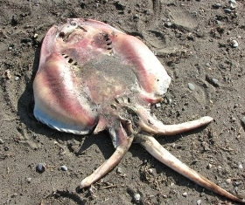

***Molly McCammon, AK Ocean Observing System***

The Alaska Climate and Health E-News reports a skate washed upon the beach in Kivalina, which may be the first documented in the Chukchi Sea. See photo at right.

**The First Regional Climate and Health Summit First Regional Climate and Health Summit Held in Northwest Arctic –** A two day summit held September 16 and 17 in Kotzebue involved individuals from local and regional governments and organizations, and state and federal agencies and universities. It was hosted by the Maniilaq Association, the regional tribal health entity, and by the Center for Climate and Health at ANTHC. Topics included climate change impacts, methods for assessment, climate models, permafrost change, water and sanitation, and food safety and security. Participants focused on developing a community-based monitoring system, and training was performed by the National Weather Service to register the only community based extreme weather event “spotters” in the region. Reported in Climate and Health E-News, sponsored by AK Native Tribal Health Consortium. Contact Mike Brubaker at [mbrubaker@anthc.org](mailto:mbrubaker@anthc.org).

**Northern Waters Task Force** The Legislature passed HCR 22 last session. The task force meets for the first time October 1 at the Anchorage Legislative Information Office. See <http://www.legis.state.ak.us/basis/get_bill.asp?bill=HCR%2022&session=26> for more details.

***Bob King, Senator Mark Begich Office***

Congress is working on a Continuing Resolution (CR) to keep government running until December. The current Federal budget expires at midnight Thursday.

**Coast Guard Reauthorization** – The House and Senate recently negotiated final language to reauthorize the Coast Guard (HR 3619). The new language passed the House and is expected to pass the Senate today. Several issues important to Alaska were removed from the bill, but numerous others remained. Bob King will circulate a summary of the final bill once it passes. You can also go to the House Transportation & Infrastructure Committee’s web page to get the negotiated version.

**Arctic Research/Energy Bills** – No action now. Maybe after election.

**President’s Oil Spill Commission**

The National Commission on the BP Deepwater Horizon Oil Spill and Offshore Drilling held a 2-day hearing Sept 27-28 in Washington DC. UAA Chancellor Fran Ulmer sits on that commission. One of the session was on Arctic issues, including Arctic needs for prevention and preparation, and baseline research. The website is [www.oilspillcommission.gov](http://www.oilspillcommission.gov).

***Amy Holman, NOAA Regional Coordinator***

**National Ocean Policy** – The deputies of the new National Ocean Council members recently met and set up 3 working groups – legal issues, communications & engagement, and data. They will soon be deciding which agency takes the lead for each of the 9 priority objectives in the new ocean policy.

***Paula Cullenberg, Sea Grant***

Paula is attending a Working Waterfront conference in Portland Maine. She is impressed with the Maine legislative involvement in the sessions.

***Gary Freitag, Sea Grant MAP agent in Ketchikan***

An invasive tunicate has been found in Sitka and they’ve received a grant to research some trial eradication techniques. Gary says they will be monitoring in Barrow and other communities.

***Caryn Rea, Conoco Phillips***

NCSE's 11th National Conference on Science, Policy and the Environment, *Our Changing Oceans,* January 19-21 2011 in Washington DC will bring together scientists, professionals, policy makers, university faculty and educated citizens from a wide range of disciplines to share their perspectives and work to address the topic at hand.  They are expecting over 1,000 attendees, with a session on balancing multiple uses (oil/gas, fishing, subsistence, shipping, etc.) in the Arctic scheduled for Jan 20 1:30-5 pm.

**Upcoming Events**

**Sept 28-30: United Fisherman of Alaska board meeting, Anchorage**

**Oct 6-8: OSRI meeting in Cordova**

**Oct 14-15: Sea Grant sponsored workshop on Marine Training for Coastal Alaskans**

**Oct 19: Joint meeting between Arctic and Western LCC’s in Anchorage**

**Oct 25-29: PICES meets in Portland OR**

**Nov 8-11: Ecosystem Based Fish Management conference in Anchorage**

**Dec: Coastal & Marine Spatial Planning mapping meeting at USGS (details TBA)**

**Jan 16-21: AK Marine Science Symposium, Anchorage**

**The next Alaska Marine Policy Forum teleconference will be Wednesday, December 1, 2010 at 1pm. If you are interested in joining the call, please email Sue Keller at** [**sue.keller@alaska.edu**](mailto:sue.keller@alaska.edu)**.**