Cook Inlet Modeling and Observation Needs

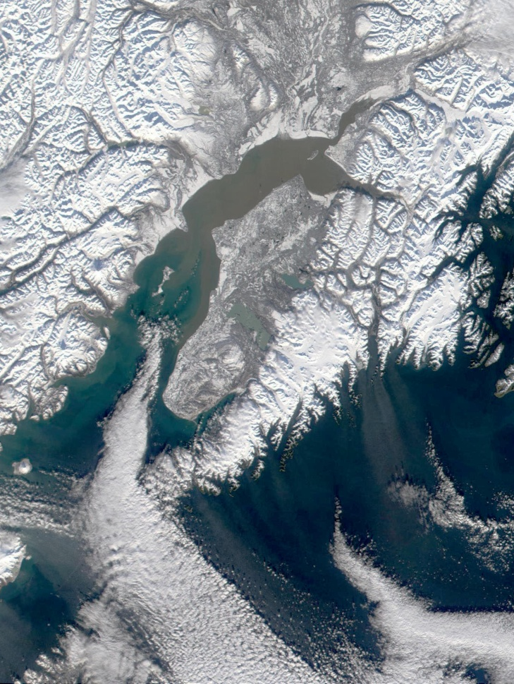

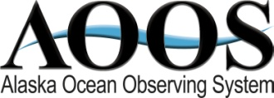

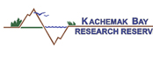
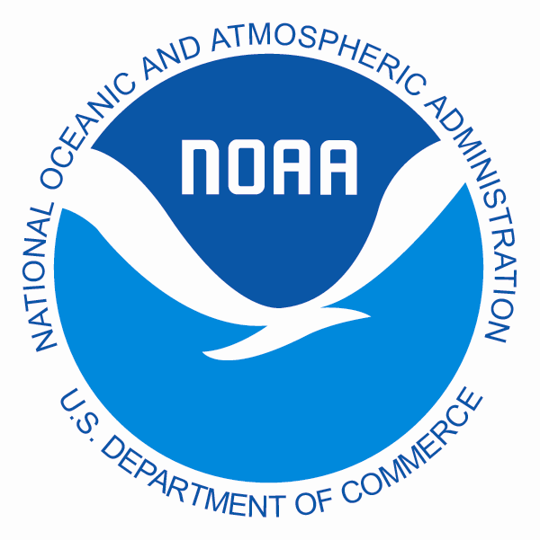
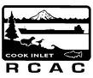
Workshop Report
March 29-30, 2010
Anchorage, Alaska

Table of Contents

ACKNOWLEDGEMENTS ………………………………………………………………….. 3

WORKSHOP GOALS AND ORGANIZATION…………………………………….. 4

COOK INLET BACKGROUND………………………………………………………….. 5

ROLE OF AOOS…………………………………………………………………………….. 6

INPUT FROM STAKEHOLDERS……………………………………………………….. 7

COOK INLET TRENDS AND CURRENT OBSERVING OVERVIEW……… 8

MODEL PRESENTATION SUMMARIES………………………………………….. 9

SUMMARY OF GROUP DISCUSSION……………………………………………….. 13

CHARGE FOR WORKING GROUPS………………………………..………………… 15

KEY RECOMMENDATIONS……………………………………………………………... 16

UPCOMING FUNDING OPPORTUNITIES………………………………………….. 17

APPENDIX A: List of Participants ………………………………………………….. 19

APPENDIX B: Workshop Agenda …………………………………………………… 21

Acknowledgements

AOOS would like to recognize the members of the Steering Committee who helped design the workshop, review draft agendas, identify participants, and provide other support. These include Amy Holman, Kris Holderied, Molly McCammon, Megan Murphy, Sue Saupe, and Carl Schoch.

A special thanks also goes to Scott Pegau and the Oil Spill Recovery Institute (OSRI) for co-sponsoring the workshop and generously providing funds for the venue and food for our first day at the Downtown Marriott hotel.

We would like to thank all the participants who attended and contributed their time, ideas, and energy towards improving our understanding of Cook Inlet. Many individuals gave presentations on their research and models, including Carl Schoch, Steve Okkonen, Eddie Zingone, Peter Olsson, Ray Chapman, Guarav Singhal, Erin Eggleston, Changsheng Chen, Yi Chao, Rich Patchen, Tal Ezer, John Whitney, Doug Jones, Carter Ohlmann, and Sue Saupe.

We also greatly appreciated hearing from stakeholders about how models and forecasting could better meet their operational needs. Those who provided input to the group included Barbara Mahoney, Monty Worthington, Brett Jokela, Sue Saupe, Peter Miccichi, Bob Ward, and Vince Tillion.

Workshop Steering Committee
Amy Holman – NOAA Regional Collaboration Team
Kris Holderied – NOAA Kasistna Bay Lab
Molly McCammon – Alaska Ocean Observing System
Megan Murphy – Kachemak Bay Research Reserve
Sue Saupe – Cook Inlet Regional Citizens Advisory Council
Carl Schoch – AOOS Consultant

Workshop Coordinator
Darcy Dugan, Alaska Ocean Observing System

With funding support from
The Oil Spill Recovery Institute

Workshop Goals and Organization
On March 29 -30 2010, the Alaska Ocean Observing System (AOOS), in partnership with the Oil Spill Recovery Institute (OSRI), the Cook Inlet Regional Citizens Advisory Council (CIRCAC), the Kachemak Bay Research Reserve (KBRR), and National Oceanic and Atmospheric Administration (NOAA), held a two-day workshop in Anchorage focused on ocean observations and numerical forecast models in Cook Inlet.

The purpose of the workshop was three-fold:

- Provide a forum for the modeling community to share information on existing numerical modeling efforts for circulation and forcing conditions in Cook Inlet and the Northern Gulf of Alaska;
- Discuss strengths and weaknesses of modeling efforts, and gaps in ocean observations to support these models; and
- Assess the needs for existing and future numerical forecast models and the observations to support them.

The desired outcome of the workshop was to develop a conceptual framework for a circulation model system in Cook Inlet, building from existing efforts (including the Prince William Sound Observing System), and including ideas for how such a system could be run operationally.

More than 40 people attended including modelers, agency managers, and stakeholders. Stakeholders included representatives of the oil industry, waste water treatment, ocean renewable power, fishing, marine pilots, oil spill response, beluga management, and the Mayor of Soldotna.

The workshop began with by hearing from stakeholders about their needs for modeling and forecasts in Cook Inlet, and their perspectives on what components were most important to them. Stakeholders spoke or showed short presentations on what type of work they were doing in Cook Inlet and what specific observing, modeling, or forecasting would be most helpful in meeting their operational needs.

A complete set of power point presentations presented from both modelers and stakeholders is available at www.aoos.org.

The majority of Day 1 focused on presentations showcasing existing wind, wave, and circulation models. Day 2 was devoted to group discussion about what type of data and information gaps existed, what models needed to be strengthened and developed, and what types of collaboration and synergies could be fostered to move forward. The workshop culminated by establishing several working groups, and identifying practical steps for those groups to meet shared goals.

An agenda and list of participants are included as Appendices to this report and are also posted on the AOOS website.

Cook Inlet Background
Cook Inlet is a 180-mile long water body located in southcentral Alaska. While it is a tiny fraction of the state’s coastline, it incorporates almost every coastal use in Alaska – recreation, commercial fishing, sport fishing, subsistence, tourism, oil and gas, mining, shipping, conservation, search and rescue, and scientific research. The wide variety of users in the inlet results in a wide variety of needs to understand and operate safely in its waters and along its coastline.

Cook Inlet oceanography is complex. Thirty foot tide ranges, mudflats, sea ice, and large glacial rivers all contribute to complicated circulation patterns that change hourly, daily, and seasonally. Major external factors such as the Aleutian Low pressure system, the Alaska Coastal Current, and the freshwater inflow affect both the physical characteristics of the Inlet and the biota that live there. The challenge of understanding such an intricate and dynamic system has attracted scientists from around the country to research and model its meteorology, waves, and circulation.

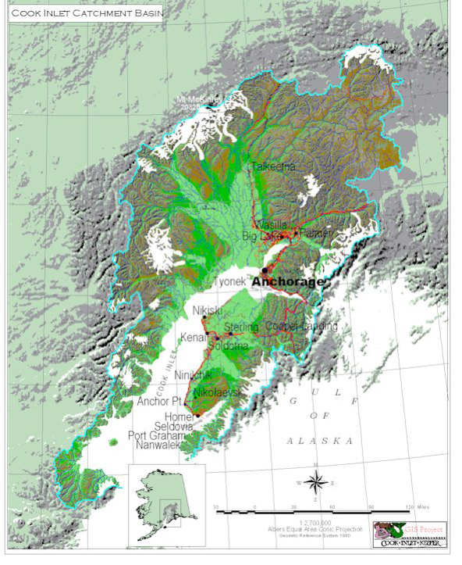
Figure 1. The Cook Inlet watershed extends from Mt. McKinley in the north to the Gulf ofAlaska along the southcentral coast of Alaska. (From: Cook Inlet Keeper www.inletkeeper.org). Note: the drainage area is within the blue line.

The human factors are equally intricate. Situated next to the Matanuska-Susitna Borough, the Municipality of Anchorage, and the Kenai Peninsula Borough, it borders roughly 61% of Alaska’s total population. Constant ship traffic streams in and out of the Inlet, delivering 95% of Alaska’s freight to the Port of Anchorage. Additionally, Cook Inlet’s waters support a multi-million dollar commercial fishing industry, with over 1,500 permitted vessels. Residents and visitors travel long distances to partake in sport fishing and recreational boating, and subsistence fishing and clamming continue to sustain many local communities. Also, the region has been tapped as a rich source of fossil fuels. Oil and gas deposits were first developed in 1958 and by 2000, 7 oil fields and 17 natural gas fields had produced a cumulative 1.2 billion barrels of crude oil and 5.6 trillion cubic feet of natural gas (CIRCAC 2000).

Cook Inlet also has multiple resource managers and stewards. To protect some of its most valuable coastal resources, Cook Inlet includes seven designated Critical Habitat Areas, three State Game Refuges, two National Wildlife Refuges, two National Parks, a State Game Sanctuary, a State Wildlife Refuge, and a National Estuarine Research Reserve. The recent proposed critical habitat designation for the endangered beluga whale covering the entire upper part and western coast of the Inlet, as well as Kachemak Bay, adds an additional layer to an already extensive management scenario.

As the population center around Cook Inlet continues to grow, the multiple uses within Cook Inlet will likely increase. Having the scientific information to make accurate marine forecasts as well as provide information for planning and safety, will be critical in managing Cook Inlet for a sustainable future.

Role of AOOS
The Alaska Ocean Observing System is one of 11 regions across the country that provides an interface between local users and the national Integrated Ocean Observing System (IOOS). The region encompasses Alaska’s entire coastline from the Dixon Entrance south of Ketchikan, through the Gulf of Alaska, Aleutian Islands, Bering Sea, and Chukchi and Beaufort Seas in the Alaskan Arctic. The mission of AOOS is to address regional and national needs for ocean information, gather specific data on key coastal and ocean variables, and ensure timely and sustained dissemination and availability of these data. AOOS’s mission includes:

- Identify priorities for coastal and ocean observations and information based on the needs of users of Alaska’s coasts and oceans;
- Coordinate State, Federal, local and private interests at a regional level to meet the priority needs of user groups in the Alaska region;
- Identify gaps in existing ocean observing activities and data, make recommendations for needed enhancements to both Federal and non-Federal assets, and fill gaps when appropriate;
- Increase efficiencies of existing ocean observing activities and data;
- Enhance the usefulness of ocean observations for a wider variety of users; and
- Integrate observations and data through data management, planning, coordination and facilitation.

With respect to data, AOOS seeks to provide a centralized location for:
- Any real-time ocean and coastal data;
- Data and information products on ocean conditions such as wind and current speed and direction, wave height, sea temperature and salinity, and more;
- Enhancements to existing NOAA weather buoy data for specialized local needs;
- Processed satellite data providing Alaska-wide information on sea-surface temperature, ocean color (chlorophyll) and wind;
- Surface current data from available high frequency radar; and
- Eventually data about fish, birds and marine mammals, the environmental effects of human activities, and any other information that can be used with the physical data to predict future changes to the ocean ecosystem.

AOOS helps develop partnerships between data providers and users from both private and public sectors that use, depend on, study and manage coastal environments and their resources in a region. For more information on AOOS, please see www.aoos.org.

AOOS recognizes the critical modeling and observing needs of Cook Inlet, and has chosen to put efforts into the region in the coming years. Due to the relatively dense population around its waters, the multiple uses that take place there, and the complicated oceanography and climatology, Cook Inlet needs a coordinated and collaborative approach from modelers, managers, and stakeholders. AOOS seeks to play a role as a facilitator and collaborator, working with scientists, modelers, managers, and stakeholders to improve our collective understanding of the Inlet.

Stakeholder Input
Sue Saupe, Cook Inlet Regional Citizens Advisory Council
Focus: insure proper response measures are in place in case of an oil spill. Right now there are gaps in data due to environmental monitoring.
Current work: CIRCAC has made observational efforts to improve their ability to model the Calgin Island area. CIRCAC put some money into model but it has limitations and does not incorporate convergence zones or baroclinic/barotropic flow.
Needs: Good 2D and 3D models to anticipate oil spill trajectories.

Barbara Mahoney, NOAA NMFS
Focus: Protection of belugas
Needs: Information on point source dispersion (oil or toxic spills, floating, dissolved, & sinking); mixing rates and residence time of water masses; storm surge and unusual tide events; salinity and temperature by date, location, depth. Need to have ideas of circulation for safe live stranding responses. They are also interested in changes to Cook Inlet with Climate Change over time.

Monty Worthington, Ocean Renewable Power Co.
Focus: Safely and effectively instating a tidal power system in Cook Inlet.
Current work: They have work permits for a 5MW project near Fire Island.
Needs: Understanding of how to use circulation models in the project development process with a hydrokinetic focus. Modeling could be used at preliminary stages to determine site selection / site characterization, determine the differences in ebb/flood tide velocities, and help focus field efforts. Modeling could also be used to determine patterns of sediment transport, power extraction to tidal range, and impacts of power extraction to water discharge, exchange, & mixing.

Brett Jokela, Anchorage Water and Wastewater Utility
Focus: Wastewater discharge, mixing zones, how toxics in output are dispersed in Cook Inlet
Current Work: environmental monitoring to ensure discharge outputs don’t affect marine biota diversity (section 308 of the Clean Water Act). They have had 20+ yrs of clean discharge and no environmental impact, but concerns have been raised about effluent impacts after immediate discharge. Currently developing biological monitoring protocols with CH2mHill & EPA. Developing an EFDC model with Coastline Engineering.
Needs: Modeling to show effluent trajectories and what areas to continue monitoring, especially for toxins that weren’t regulated. Also information on sediment deposition, transportation, and impacts of effluent on whales and other biota

Vince Tillion, SW Alaska Pilots Association
Focus: Managing tankers and container ships in Cook Inlet, representing the State of Alaska
Needs: Available to answer questions about shipping

Captain Bob Ward, Homer Charter Association:
Focus: Marine forecasts for fishermen
Needs: Accurate and up to date ocean forecasts. There are concerns with physical locales of monitoring stations, particularly from the west and southwest. There are biases at Augustine and Flat Island. The Seldovia station is sheltered, the Homer station is partially sheltered, and the Kodiak Buoy is too far offshore. The Barren Island station is down (functioned less than 20% of time) and the Anchor Pt buoy has been down 50% of time. There is no good report of seas.

Peter Macciche, Conoco Phillips, Mayor of Soldotna, 20 year commercial fisherman
Focus: Industry, borough, and fishing
Needs: Several things are missing from their oil spill ‘drill’; they need more effective ways of understanding the dispersion of oil. There is also a need to incorporate observations by people who are out on vessels.

Cook Inlet Trends and Current Observing Overview
Steve Okkonen from the University of Alaska helped participants at the workshop understand some general trends in Cook Inlet trends and where to look for information.

Okkonen noted the following points of contact for projects:
Cook Inlet current meter data (Tide.Predictions@noaa.gov)
CIRCAC spill trajectory model (saupe@circac.org)
Cook Inlet hydrography (wspegau@pwssc.org)

He emphasized the importance of freshwater forcing on Cook Inlet hydrography and circulation at tidal, seasonal, and interannual time scales. He also noted high resolution bathymetry was needed for simulation of Cook Inlet tide rips. Okkonen suggested that tidal flats, despite their relatively small surface area, were important heat sources/sinks in the Cook Inlet heat budget.

Carl Schoch from AOOS provided an overview of the current observations being collected in Cook Inlet. The array of real time or operational observing system components in Cook Inlet includes weather stations and buoys, wave buoys, water level recorders, water quality sensors, web cams, and numerical models of atmosphere and ocean circulation, and wave conditions. There are also many short term projects and instruments not delivery data in real time that may be modified for use in an observing system.

There are three weather buoys useful for an observing system in Cook Inlet, two are in the Gulf of Alaska and the third is in Shelikof Strait. Land based weather stations in the Cook Inlet region are reporting through:
- National Weather Service Cooperative Weather Program (9: http://www.weather.gov/om/coop/)
- The National Data Buoy Center (5: http://www.ndbc.noaa.gov/maps/Alaska.shtml)
- The Physical Oceanographic Real Time System (2: http://tidesandcurrents.noaa.gov/ports.html)
- The Alaska Meteor Burst Communication System (16: http://ambcs.org/)
- The Hydrometeorological Automated Data System (26: http://www.weather.gov/oh/hads/)
- The Remote Automated Weather Stations (12: http://www.fs.fed.us/raws/)
- The Road Weather Information System
(9: http://www.dot.state.ak.us/iways/roadweather/forms/AreaSelectForm.html)
- The Automated Surface Observation Stations (5: http://www.weather.gov/asos/)
- The System Wide Monitoring Program (2: http://www.nerrs.noaa.gov/RCDefault.aspx?ID=53)

Some of these weather stations report observations through more than one system. Many of these station observations, as well as many private or amateur weather station observations, are available through the Meteorological Assimilation Data Ingest System (http://madis.noaa.gov/). There is a weather radar system operated by the NWS at Nikiski. There are two wave buoys in Cook Inlet one in Kennedy Entrance and the other off Anchor Point. The weather buoys in the GOA and Shelikof Strait also provide wave conditions. There are water level recorders in Nikiski, Anchorage and Seldovia. The latter is co-located with a seismometer operated by the University of Alaska Fairbanks. Surface water temperature is observed by the weather buoys and also at the Homer and Seldovia harbor entrances.

There are about ten web cams in the Cook Inlet region observing real time ocean conditions, and 8 cameras observing sediment transport as part of the ARGUS program (http://www.coastalwiki.org/coastalwiki/Argus_video_monitoring_system). There is an operational numerical atmospheric forecast model operated by the Alaska Experimental Forecast Facility (http://aeff.uaa.alaska.edu/), and a wave forecast model is in development by Texas A&M University (http://www.tamug.edu/mase/Wave_file/CI.htm).

In addition to the real time components listed above, there are other projects that have been demonstrated and may be useful to add to the observing system. These include HF radar, an ocean circulation forecast model, ice thickness monitoring, a vessel mounted recording thermosalinograph, instrumented mooring arrays, and hydrographic transects.

Model Presentation Summaries
Eddie Zingone – National Weather Service, Marine Forecasts
Cook Inlet has two different weather marine forecast zones (three, including Kachemak Bay) which are numbers 140, 141, and 130. Two NWS buoys are located there but both are down presently, and difficult to maintain due to sea ice. NWS forecasters use the Alaska Wave model with 10 km resolution, nested in NOAA Wave Watch III. They also have an Alaska Wave Model with 4 km resolution but it doesn’t cover northern Cook Inlet. The SWAN model from Texas A&M is available on the internet but difficult for operational forecasters to use. They need it to input directly into AWIPS and other graphic forecasting tools. Additionally, there are wind model resolution differences (GFS40 = 40 km, NAM12 = 12 km, Local Anchorage office WRF = 3km, GFE East = 3km). Canadian SAR for wind speeds shows strong NW winds out of the Kamishak Gap, and accelerating NE winds down the Inlet. There are very strong spatial gradients in wind speed. Some links are here:
SWAN model: http://www.tamug.edu/mase/Wave_file/CI.htm
SAR wind archive: http://Fermi.jhuapl.edu/sar/stormwatch/web_wind/

Peter Olsson – Alaska Experimental Forecast Facility (UAA), Atmospheric Modeling
Olsson runs a Weather Research and Forecasting (WRF) model twice a day (00 and 12Z) to produce 48-hour forecasts for southcentral AK and north Gulf of Alaska. Olsson described the models as a numerical approximation of the physical approximation of how we think the atmosphere works. The model has a coarse grid (12x12km), and a fine grid (4x4km over Cook Inlet and PWS), and the vertical coordinate is pressure. The model runs over land as well as water, so the entire rectangular area within the grid boundary is covered by the computational grid. WRF has a complete surface package (soil moisture, snow cover, ET, etc), full multi-stream radiation model, and complete cloud microphysics. WRF uses a different physics core (ARW) than the NAM (NWS WRF variant). Neither variant is better – they are slightly different tools for different jobs. WRF predicts: (3-d) horizontal and vertical winds, temperature, geopotential height, mixing ratios of cloud content variables (rain, cloud droplets, hail, snow), and radiative fluxes.

Ray Chapman – U.S. Army Corps , Wave Hindcast
USACE has recently completed a wave hindcast project for the Aleutians, western and northern Alaska. Historical data was used to develop the model that can predict wave height at 469 modeled locations with a ¼ degree resolution. This product can help validate models, understand trends, predict sedimentation, and report maximum wave events to help design coastal infrastructure. There is a data archive from 20-yr wind and wave hindcast study online at http://frf.usace.army.mi/wis/ak/ak_main.html. Contact Bob Jensen at Robert.E.Jensen@usace.army.mil for questions.

Gaurav Singhal – Texas A&M, Cook Inlet Wave-Current Forecasting System
Vijay Panchang and Guarav Singal have a Cook Inlet wave-current forecasting system. Additionally, their NWS CSTAR proposal was selected for funding with at start date of May 1, 2010. The scope of work includes:
- Waves: SWAN (DELFT), WAVEWATCH III (NCEP)
- Currents/Water levels: EFDC (EPA), ADCIRC (USACE), Dr. Andrey Proshutinsky’s model
- Wave-current interaction (coupling of wave model & circ model)
- Wetting & drying of shallow area (ex Knik & Turnagain Arms)
This will primarily be a research tool. Singhal showed the preliminary wave model, and expressed the desire to switch to the WRF model and incorporate local topography. He also showed the preliminary current model output (EFDC) which has no winds or freshwater input.

Erin Eggleston – University of Alaska Anchorage, student of Prof. Tom Ravens
Eggleston and Ravens are working with a SWAN model grid. The grid is more refined in the upper inlet, and goes all the way to Seldovia. They are trying to use the best available bathymetry. They found big differences in observed versus predicted water levels at Anchorage when forced from Seldovia, and better when forced from Nikiski. Eggleston noted there are not water elevations stations on the west side. In general, tidal flat areas are poorly defined which could be influencing the poor modeling in upper inlet. Ravens mentioned the ADCP data from Knik Arm bridge project could be used for model validation. He also said they were developing a flow model which would involve adding waves and then sediment.

Changsheng Chen – University of Massachusetts, FVCOM Cook Inlet Model
Chen is working in collaboration with Andrey Proshutinsky, Mark Johnson, Robert Beardsley, and H. Lin on a FVCOM current model for Cook Inlet. Because the Inlet has strong tidal motions, complex geometry and bathymetry it is the perfect place for an unstructured model. The VCOM model has a horizontal resolution of 126 meters near the coast and 13km over the shelf with a vertical resolution at 11 sigma-level. The major result is that FVOM has successfully simulated the large variation of the tidal elevation and strong tidal currents. Additionally, the unstructured grid has helped resolve the irregular coastline, providing a realistic simulation of the water exchange through narrow water passages, around islands and near the coast. Information needed to improve FVCOM includes: better bathymetry (particularly in Turnagain Arm), one month of measurements of sea level variability across Cook Inlet open boundaries with resolution of 10-15 km, climatological fields of water temp and salinity needed for entire Cook Inlet for baroclinic model, and improved accuracy of Cook Inlet wind forecasts.
Website: http: //fvcom.smast.umassd.edu/research_projects/CIAlaska/index.html

Yi Chao – NASA Jet Propulsion Lab, ROMS Model
Chao began by emphasizing the need for a single Cook Inlet portal where you can access dataset s and model outputs in a common format. He then laid out a conceptual framework of what a 3D ocean circulation forecasting system should consist of:
- Atmospheric forcing (wind, heat, rain) from a high-resolution model
- Freshwater forcing (rivers, runoff) from a hydrological model
- Lateral boundary conditions from a large-scale 3d ocean circulation model (with tides)
- Observational data sets (surface & subsurface, T/S & current)
- Advanced and computational efficient data assimilation scheme

The stakeholder requirements should include:
- Systematic validation with quantifiable uncertainties
- Ability and standard/easy link to other modeling modules (biogeochemical, ecosystem, and fishery)
- Stake holder/ user driven products based on model variables
- Access to model output with common interface, standard formats, and tools for analysis (time series over 1 or 2 yrs)

Chao then made a brief overview of a ROMS-Based Ocean Forecast System for Application Users in several different regions, including SCCOOS, CeNCOOS, MARCOOS and AOOS. In addition to circulation models, Chao emphasized the role of assimilation of both in-situ and remotely sensed data including both satellite and land-based high-frequency (HF) radar data. Experiences from the California HF radar program showed the importance of HF radar data assimilation, particularly when the radial velocity is used for data assimilation. It is also important to involve multiple models with different error statistics so that a multi-model ensemble can be constructed.

Chao concluded his talk by stating several challenges. We don't have a federal agency that can perform the operational ocean forecasting like the operational weather forecasting. Thus, it remains a challenge how to transition these forecasting models developed at the academic institutions from research to 24/7/365 operations. Reaching out to the application users (beyond scientists) so as to identify the refine the user requirements will remain a major task for IOOS and different RAs.

Finally, Chao pointed out that the IOOS and RAs need to establish a standard metric that can be used to evaluate the success of these forecasting system, and therefore to justify the appropriate investment.

Rich Patchen – NOAA-National Ocean Service (NOS), Implementation of NOS Cook Inlet and Shelikof Strait Operational Forecast System
NOS has been funded to develop improved navigational products and support known requirements in Cook Inlet including marine operations, resource management, coastal science, oil spill response, and renewable energy. Patchen will be creating a model to produce two products: 1) web-enabled tide and tidal current predictions, and; 2) an Operational Forecast System. The model is a ROMS implementation with wetting/drying and will have 1.8 km resolution in lower Cook Inlet to 85m in upper Cook Inlet, and 22 levels of vertical resolution. The climatology is used to: initialize model hindcasts; provide open/ocean lateral boundaries conditions for long hindcasts; validate those hindcasts; quantify trends and anomalies; characterize anthropogenic influences on the salinity and temperature regime of the region; etc.

Tal Ezer – Old Dominion University, Inundation Modeling & Remote Sensing in Cook Inlet with Applications for Morphology Changes and Beluga Whales Movement
Ezer, in collaboration with Oey, has developed a POM-WAD scheme to work with 3D ocean circulation models including stratification, wind, rivers, eddies, deep-ocean cir, surface waves, & data assimilation. The POM-WAD model uses a curvilinear grid (.5-1 km), topography of mud-flat areas, temperature and salinity stratification, winds from local NOAA stations, and river runoff. The applications for this model include tide processes (tidal rips and tidal bores), beluga whale movement, and remote sensing.
http://www.ccpo.odu.edu/~tezer/Pub.html

John Whitney – NOAA Hazmat, GNOME and Oil Spill Response
NOAA hazmat needs ocean circulation information for oil spill response. 95% of oil spills in Cook Inlet are in the upper inlet, and most spills are from platforms. Crude oil is the predominate medium, followed by diesel. There is need for a high resolution circulation model for upper Cook Inlet. Some observations by Whitney include the ebb tide is stronger than the flood tide on the left side and the reverse is true on the right side. Net currents carry oil from east to west rapidly immediately south of the forelands. Net currents can move clockwise around Kalgan Island. Rip zones tend to attract and temporarily submerge oil, mostly on ebb tides.

Whitney noted the following needs:
- Better definition of the convergence zones N of the Forelands
- Better understanding of net circulation on W side of Kalgan
- What’s the situation to the north side of Kalgin Island? Is this a quiescent zone?
- Obtain monthly gauging data of 3 major rivers entering N CI – Matanuska, Knik & Susitna
- Characterize forelands eddies on both the E & W sides
- Characterize convergence zone off of Cape Douglas? Major player in Exxon Valdez spill.
- Watch wood chips for convergence zones
- Verify, modify, and ground truth Britch net current diagram.

Ray Chapman – US Army Corps of Engineers, Port of Anchorage Deepening and Expansion: Hydrodynamic Modeling
The USACE has developed a calibrated ADCIRC 2D unstructured hydrodynamic model of Cook Inlet, Knik Arm, and the Port of Anchorage in order to evaluate the impact of port expansion and deepening on circulation and navigation. Port expansion started last year and the current depth footprint of 35 feet (MLLW) is planned to increase to 45 feet. The Port of Anchorage requires annual maintenance dredging. The hydrodynamic modeling performed by USACE supports sediment transport, ship simulator and ship mooring forces models. The modelers found that initial simulations consistently under predicted water level at Anchorage, which required refinement of the geometric representation of the Knik Arm mudflats, which significantly influences circulation within the Port. In 2002 and 2006, NOAA and the USACE Alaska District collected roving ADCP current measurements along selected transects within Knik Arm. These data were used to validate the model predicted representation of the Point Woronzof Flood gyre, as well as the Cairn Point Ebb gyre.

Carter Ohlmann – UC Santa Barbara, Effluent Fate & Transport
Fate and transport is an important aspect of regional operational models, and have applications for oil, effluent, ballast water, and search and rescue. Ohlmann presented an observational paradigm for monitoring the fate and transport of an effluent plume, emphasizing that observations are a necessary component of model-based studies and applications. He showed an example of four effluent fate and transport models tracking the effluent plume off the California coast, and the noticeable difference in their results. Ohlmann suggested an observational plan to complement the effluent model. Some important components include moorings at the plume outfall to measure temperature and currents, drifter releases, boat sampling following the drifters (to measure microbiology and CTD), and microbiology measurements in the surf zone along the coast.

Sue Saupe – Cook Inlet Regional Citizens Advisory Council, Effluent Fate and Effects/Mixing Zones
Saupe began by discussing mixing zones and Clean Water Act compliance. In Anchorage, there is a high level of wastewater discharge – millions of gallons each month. There have been a lot of measurements both in and out of mixing zones, as well as upstream and downstream. However, better models are needed to guide the size of the mixing zones, and we must use caution when interpreting the model output. Increased environmental monitoring is necessary to see if toxins are accumulating in surrounding locations. Waste water discharge in an area with a high sediment load may mobilize more pollutants in the sediment, and eventually concentrate them in the upper trophic levels of the food web. Good models can accurately track transport and better characterization dilution rates. Saupe also showed an example of sensitivity analysis on impact of stratification.

Summary of Group Discussion (Day 2)
The objectives for the discussion were to discuss and develop the following:
- Collaborations
- Observations most needed
- Ideas for linking existent models with larger models
- Ideas for validating models
- How to deal with data management
- Long-term, climate-related scale
- Identify user groups
- Recommendations for steps forward
- Tools & products desired / ways to access information
- Plan for model coordination & ensembling
- Standard bathymetry & coastline [shared databases] set
- What resources exist to house and maintain shared databases

Twenty-three people participated on Day 2 of the workshop. Discussion started off with the importance of developing useful products for people that need them. McCammon mentioned that some of the needs included marine operations, fisheries, oil spill response, protected resources, and renewable energy. She noted the AOOS Board had appropriated $150,000 this year for Cook Inlet, which was anticipated to cover WRF wind modeling and a wave buoy. There will be new funding decisions next year. There may also be the ability to site SNOTEL stations in Cook Inlet that weren’t used in PWS.

The group agreed that a new foundation of information is needed to move models forward. Cook Inlet is complicated and we need to improve our understanding and accuracy. Carter Ohlmann noted that as a first step, we need a generalized circulation model for the Inlet to meet first order tests. This is currently lacking. Collecting backbone information for a generalized model is an achievable first step.

McCammon expressed interested in collaborating on a single Cook Inlet modeling/monitoring system and avoiding ad hoc efforts. This system would be designed to be accessible, useful, adaptable, integrated, and non-duplicative. A “Cook Inlet consortium” could focus on these efforts. There was group agreement that AOOS had a unifying role in coordinating data sets, providing sustainability, and continuity and making sure efforts go towards contributing to other efforts. There needs to be a narrow and conscious focus on what data to collect since data management can easily consume all the resources.

The topic of the new NOAA Regional Climate Center was brought up briefly, questioning its role and whether it would keep datasets and provide similar services. It was suggested that maybe the group in the room could voice suggestions for the data center’s requirements. We don’t want to have four data centers in the state, and it might be useful to create a spreadsheet of what data is out there and who could provide it. It was noted that of the entities dispersing data of information, the NWS forecast was the most popular from users – “Everyone in a boat is using it” -- with particularly high recreational use in the summer, and year-round use by marine pilots.

The conversation moved to improving forecasts, focusing specifically on (1) where are additional observations needed, and (2) what type of products should be available for users. The group decided to form three modeling working groups (meteorology, wind, and circulation).

Alaska State Climatologist Peter Olsson agreed to spearhead the atmospheric/met modeling group, in partnership with NWS forecaster Jim Nelson. Discussion jumped straight into ideas for improving meteorology forecasting. There is a clear need for observations on the west side of Cook Inlet, and most immediately this could involve placing MET stations more strategically in data-sparse areas. As mentioned in Bob Ward’s letter, and confirmed by NWS forecaster Eddie Zingone, the NE and NW winds are difficult to obtain due to the landscape. It would be wise to locate one on the south tip or near the Barren Islands to capture Shelikof Straits. Winds in the upper inlet are not as complex as the lower inlet. McCammon noted that there were several immediate opportunities to add observations: three or four MET stations, additional nodes of the Alaska Harbor Observing Network sites, and potentially the use of several SnoTel stations left over from PWS.

The group discussed the possibility of obtaining data from private companies that have met stations, such as the one collecting real time information for the proposed port development for Pebble Mine. Having access to this data would be extremely valuable. Private entities or industry may not agree to share this data; however oil and gas interests had shown a lot of generosity by helping with logistics and providing in-kind services – ship time, helicopters, boats, underwater elders. It may be possible to put observations on oil/gas platforms (most are state and not federally overseen). Participants noted that if asked to collaborate, groups like oil and gas may be willing. Among other things, contributing to science or projects that benefit the community can help their public relations.

Discussion moved on to waves. The wave modeling working group will be led by Carl Schoch and Vijay Panchang. Understanding waves in Cook Inlet is complex, and the topic is still under discussion and study. Hindcasting is being done by the Army Corps, but there is little forecasting. To date, only the SWAN and NWS/NCEP (Wave Watch III) models exists. Guarav Singhal commented that NWS was encouraging people to use Wave Watch III rather than SWAN. There is a shallow version of WaveWatch for Cook Inlet, but it’s still a structured grid and is set up in hindcast but not forecast mode. The main physical features between SWAN and WaveWatch models are similar. There was some concern about whether wave models can handle Cook Inlet conditions – strong currents, dynamic water levels/inundation, etc. Tal Ezer expressed the need for more work on coupling between waves and currents. McCammon mentioned there was potential for another wave buoy next year from CDIP in Lower Cook Inlet. This would be more for mariners and less to validate models. It was very clear to participants that there is a great need for better bathymetry. Grid cells jump from 1m to 40m and there are large portions of the inlet that haven’t been surveyed in 40 years. Compiling existing bathymetry was placed on the task list.

The group also discussed ways to verify wave data beyond buoys since buoy data is very limiting. This could include ADCP, pressure in shallow waters, satellite measurements of significant wave height, ex-bin radar, and HF radar. There are three satellites that currently have wave height available. Yi Chao volunteered to help coordinate satellite data. Scott Pegau also has data on wave monitoring through the ARGUS program from 2005 – 2007. There are further opportunities to collaborate on getting wave data out of imagery.

Discussion also touched on the utility of ship reports and the need to work with Bob Ward and others to get more reports onto the NWS ship observation network. The website is sailwx.com.

To date, there is no operational circulation model for Cook Inlet. A group led by Yi Chao, Kris Holderied, Carter Ohlmann and David Oliver will lead the circulation modeling working group. One of their tasks will involve identifying and collecting the richest data sets (people agreed 2005 and 2006). Olsson’s met group will work on forcing conditions to contribute to the circulation group.

Charge for Cook Inlet Modeling Working Groups
The chart below was the result of the brainstorming session and discussion from Day 2. This chart lays out three model-focused working groups (the 2D and 3D circulation will be combined)

The team leads (listed at the bottom of the chart) are responsible for:
- Selecting working group members and convening sessions or calls as necessary with assistance from AOOS staff.
- Filling out the table below, including:
  - What tasks are necessary to move models to operational status?
  - What can we use for validation or “filtering”
  - What value-added products could be produced
  - What are the specific user needs
  - What observations are needed to meet user needs and strengthen models
- Discussing how existing models overlap, whether new models need to be produced, and how collaboration or complementary work can be accomplished.
- Reporting back to the full working group during the May conference call
Brainstorm Chart from Group Discussion

 | Meteorological | Wave | 2D Circulation | 3D Circulation
Models | UAA | TAMU-SWAN | ADCIRC -USACE | POM-WAD
 | NWS/ANC | NWS/NCEP - WWIII | EFDC- TAMU | ROMS-JPL
 | NWS/NCEP |  | Tide: TPX 6.0 | ROMS - UAF/PMEL/Rutgers
 | UAF |  | EnPAC 2003/UNC | CIOFS- ROMS
 |  |  | IOS/Foreman | FVCOM
 |  |  |  | NCOM, HYCOM
Data Exchange |  | Wind | HF Radar
 |  | Satellite Sea level Ht | ADCP
 |  | CDIP
Validation |  | Buoy | Selected Hindcast Exp.
 |  | Ship reports
Value-added Products
User Needs | Delivery |  | Oil spill trajectory
 |  |  | Larval transport
 |  |  | Beluga locations
 |  |  | Search & rescue
 |  |  | Pollutant transport
Observational Data Needed | Model improvement validation | Upper Inlet info
 | Precipitation |  | Precipitation
Working Group Leads | Peter Olsson/Jim Nelson | Vijay Panchang/Carl Schoch | Yi Chao/Kris Holderied/Carter Ohlmann/David Oliver

(Note: thank you to Yi Chao for providing the conceptual framework of this chart for purposes of discussion)

Collecting Ancillary Data Sets and Other Tasks
The following data and information needs were identified in discussion, and were tasked to the teams below. These teams will work together to collect the information described.

- Bathymetry: Compile existing bathymetry in Cook Inlet to come up with highest resolution and most up to date data set (Carl Schoch/Kris Holderied)
- Climatology: Gather information on climatology for the region, noting what exists and what is missing (Rich Patchen and Changsheng Chen)
- Historical Database: Gather a list of rich oceanographic data sets for Cook Inlet, including what it is, where its housed, the format it’s in, and the data steward, and how to access it (Darcy Dugan/Scott Pegau/Carter Ohlmann)
- Hydrology: Find out existing information on hydrological models (line sources) and river gauges (point sources) from USGS (Darcy Dugan/Rich Patchen/Jim Nelson/Yi Chao)
- Satellite Data: Can we get remote sensing information on to help us with waves? Contact GINA or other satellite Gurus to figure out what is available. (Steve Okkonen/Yi Chao/Gary Hufford/also Rachel Potter at UAF)
- Biogeochemistry Ecosystem Models and HABS Models: assess what exists and how oceanographic models could be linked? (Kris Holderied)
- Ice – what information is available on ice thickness and density? (Kathleen Cole, Vinny Catalan - CIRCAC)
- Sediment transport: Compile existing and past work. What is the ability to model sediment transport assuming accurate current profiles are available? (Tom Ravens/Orson Smith)
- Framework and system for a Cook Inlet data exchange: Facilitate the development of a web interface, data base, and data providers to populate the system. The system will also store data that would otherwise disappear. (Molly McCammon, David Oliver, Yi Chao)
- User/Stakeholder Input: Identify the top 3 to 5 “super users” for meteorological, wave, and circulation modeling and forecasting. Acquire input on their specific observing and modeling needs, and what type of information products would be most useful. (Megan Murphy/Sue Saupe/Amy Holman)
- Brochures: Create and distribute outreach materials on Cook Inlet and the modeling/forecasting/observing efforts. (Molly McCammon and Darcy Dugan)
- “State of Cook Inlet” annual report (Carl Schoch, Molly McCammon and Darcy Dugan)
- Publications: Develop a science plan, and coordinate the writing of scientific articles (Molly McCammon and Darcy Dugan)
- Process Study Suggestion Box – we anticipate the necessary process studies will surface subsequent to working group reports (Carter Ohlmann)

Key Recommendations
Establish a Cook Inlet Working Group. Gather scientists and modelers, identify tasks to develop a modeling and observing system, and begin collaborating and communicating regularly. This has already begun as an outcome of the workshop, and will require routine follow-up and conference calls.

Establish a Cook Inlet Data Exchange. Compile resources to create a single online database that includes historical data, real-time data, and model output. This data exchange could be housed by AOOS. Among the highest priorities of data is assembling better bathymetry for Cook Inlet and creating a seamless connection of the land/water datums, particularly in tidal flats. It is hoped that NOAA/NOS could establish a Vdatum tool for Alaska as soon as possible.

Increase the Number of Observations: There are many gaps in observations necessary to strengthen models and improve forecasts. The type and location of new observations will be recommended and refined by the three modeling working groups listed earlier, as well as the stakeholder working group that will be documenting the needs of users. The workshop participants’ initial recommendations, in order of priority, included (1) CTD lines; (2) HF radar; (3) Moorings.

Develop a Cook Inlet Publication. To help educate the public and relay the need and use for Cook Inlet oceanographic information, a brochure or publication should be developed. This will help publicize the project and also create further opportunities for partnerships and funding.

Upcoming Funding Opportunities
The group will need to keep abreast of upcoming funding opportunities to help implement recommendations and actions decided further along in the process. People who hear of potential funding opportunities should contact Darcy Dugan at AOOS who will communicate the information to the entire group. From there, working groups can be established to apply for proposals.

Several potential funding opportunities in the near future surround the topics of:
- Renewable Energy
- Beluga listing
- Marine Spatial Planning
- North Pacific Research Board
- Possible earmark for Pacific coast

Appendix A: Workshop Participant List

COOK INLET MODELING WORKSHOP: Participant List March 29-30, 2010
Name | Organization | Email
Bill Britt | Chevron | BrittB@chevron.com
Jason Brune | Resource Development Council | jbrune@akrdc.org
Yi Chao | NASA Jet Propulsion Lab | Yi.Chao@jpl.nasa.gov
Ray Chapman | U.S. Army Corps | Raymond.S.Chapman@usace.army.mil
Laura Chartier | The Nature Conservancy | lchartier@tnc.org
Heather Crowley | Minerals Management Service | heather.crowley@mms.gov
Andy Dixon | NOAA - NWS | andrew.dixon@noaa.gov
Darcy Dugan | Alaska Ocean Observing System | dugan@aoos.org
Erin Eggleson | University of Alaska Anchorage | erineggleston@gmail.com
Ken Eisses | U.S. Army Corps | kenneth.j.eisses@poa02.usace.army.mil
Tal Ezer | Old Dominion University | tezer@odu.edu
Amy Holman | NOAA - NWS | Amy.Holman@noaa.gov
Kris Holderied | NOAA - Kasistna Bay Lab | Kris.Holderied@noaa.gov
Gary Hufford | NOAA - NWS | Gary.Hufford@noaa.gov
Brett Jokela | Anchorage Water and Wastewater Utility | brett.jokela@awwu.biz
Doug Jones | Coastline Engineering | dougjones@gci.net
Molly McCammon | Alaska Ocean Observing System | mccammon@aoos.org
Peter Micciche | ConocoPhillips/City of Soldotna | peter.a.micciche@conocophillips.com
Barbara Mohoney | NOAA - NMFS | Barbara.Mahoney@noaa.gov
Mike Munger | Cook Inlet Regional Citizens Advisory Council | munger@circac.org
Megan Murphy | Kachemak Bay Research Reserve | megan.murphy@alaska.gov
Dave Musgrave | Terrasond | fbksdave@gmail.com
Jim Nelson | NOAA - NWS | James.A.Nelson@noaa.gov
Steve Okkonen | University of Alaska | okkonen@alaska.net
Carter Olhmann | UC Santa Barbara | carter@icess.ucsb.edu
David Oliver | Terrasond | Doliver@terrasond.com
Peter Olsson | University of Alaska | olsson@aeff.uaa.alaska.edu
Rich Patchen | NOAA - NOS | rich.patchen@noaa.gov
Scott Pegau | Oil Spill Recover Institute | wspegau@pwssc.org
Sue Saupe | Cook Inlet Regional Citizens Advisory Council | saupe@circac.org
Mark Savoie | Kinnetic Labs | msavoie@kinneticlabs.com
Carl Schoch | Coastwise Services | cschochak@gmail.com
John Whitney | NOAA Hazmat | john.whitney@noaa.gov
Monty Worthington | Ocean Renewable Power Company | mworthington@oceanrenewablepower.com
Eddie Zingone | NOAA - NWS | eddie.zingone@noaa.gov
By Phone:
Changsheng Chen | University of MA | c1chen@umassd.edu
Vijay Panchang | Texas A&M University | panchanv@tamug.edu
Tom Ravens | University of Alaska Anchorage | aftmr@uaa.alaska.edu
Guarav Singal | Texas A&M University | singhalg@tamu.edu
Vince Tillion | SW Pilots Association | vincetillion@alaska.net
Aijun Zhang | NOAA | aijun.zhang@noaa.gov

Appendix B

Cook Inlet Modelers Workshop
AGENDA
March 29-30th, 2010 Anchorage, Alaska
Monday Location: Anchorage Downtown Marriott: 820 W. 7th Ave
Tuesday Location: Alaska Ocean Observing System 1007 W. 3rd Ave

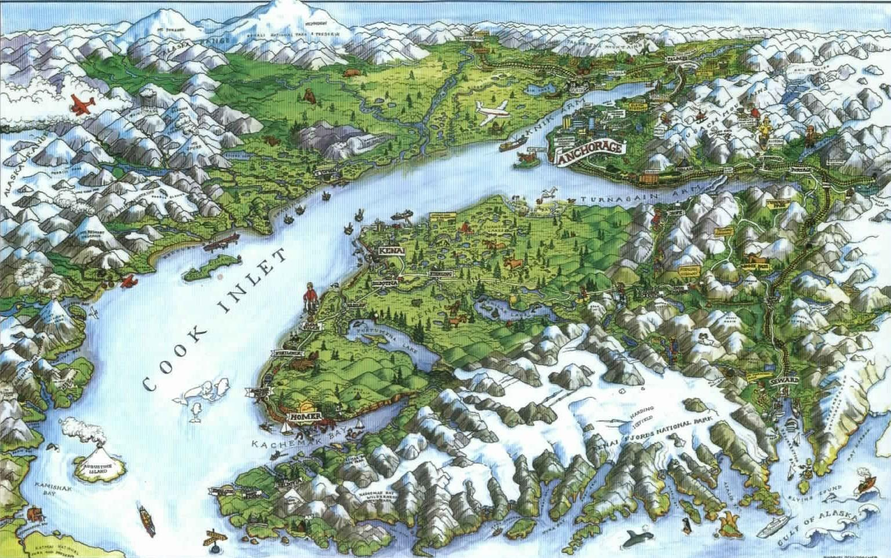

Purpose:
- Provide a forum for the modeling community to share information on existing numerical modeling efforts for circulation and forcing conditions in Cook Inlet and the Northern Gulf of Alaska
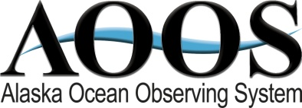
- Discuss strengths and weaknesses of modeling efforts, and gaps in ocean observations
- Assess the needs for existing and future numerical forecast models and the observations to support them

Expected outcome:
- Develop a conceptual framework for a circulation model system in Cook Inlet, building from existing efforts ( including the Prince William Sound Observing System), and including ideas for how such a system could be run operationally

Workshop Sponsors:
- Alaska Ocean Observing System (AOOS)
- Oil Spill Recovery Institute (OSRI)
- Cook Inlet Citizens Advisory Council
- NOAA Alaska Regional Collaboration Team
- NOAA Kasitsna Bay Laboratory
- Kachemak Bay Research Reserve
--- DAY 1 ---

8:30 am Introduction and Welcome

8: 45 am Stakeholder/User presentations (5-10 min each, focused on why we need the models)
    - Oil Spill Monitoring and Response – Sue Saupe, CIRCAC
    - Agency Management/Belugas –Barbara Mahoney, NOAA
    - Tidal Energy – Monty Worthington, Ocean Renewable Power Company
    - Waste Water – Brett Jokela, AWWU
    - Shipping
    - Marine Pilots
    - Fishing
    - Fish biologists
    - Oil & Gas

10am Summary on what we know about Cook Inlet
Background and General Physical Oceanography - Steve Okkonen, UAA
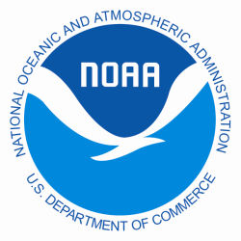
An Overview of the Current Observing System – Carl Schoch, AOOS consultant

10:30am Break

10:45am Model Presentations (15 min each)
After each section, there will be group discussion on what information exists, strengths and weaknesses of models, identified gaps, and recommendations for observing

Wind Model s
- Cook Inlet Marine Weather Forecasts – Eddie Zingone, National Weather Service
- Atmospheric Modeling over Cook Inlet and Prince William Sound – Peter Olsson, UAA
- Group Discussion (20 min)

11:35am Waves Models
  - U.S. Army Corps Wave Hindcast – Ray Chapman (for Bob Jensen), US Army Corps
  - SWAN Model for Cook Inlet – Vijay Panchang, Texas A&M University, by phone
  - Group Discussion (20 min)

12:30 pm ---- Lunch Provided ----

1:30 pm Circulation Models
  - Tidal, Wind, and Buoyancy-Driven Currents in Cook Inlet: An Application of FCOM –Chen Changsheng, U Mass, by phone
  - Strategy to Develop a 3D Ocean Circulation Forecasting System for Cook Inlet - Yi Chao, NASA Jet Propulsion lab
  - The Implementation of a NOAA/NOS Cook Inlet and Shelikof Straits Operational Forecast System – Rich Patchen, NOAA
  - Inundation Modeling and Remote Sensing in Cook Inlet with Applications for Morphology Changes and Beluga Whales Movement– Tal Ezer, Old Dominion University
  - Group Discussion (30 min)

3:00pm Break

3:15pm Additional Model Applications (15 min each)
  - Oil Spill Response – John Whitney, NOAA Hazmat
  - Port of Anchorage – Ray Chapman, NOAA
  - Modeling Transport of Wastewater Discharge Constituents in Upper Cook Inlet – Doug Jones, Coastline Engineering
  - Effluent fate & transport – Carter Ohlmann, UC Santa Barbara
  - Effluent fate & transport in Cook Inlet – Sue Saupe, CIRCAC (5 min)

4:20pm Group Discussion
(Identify any hold-over topics for Day 2)

5pm Adjourn

--- DAY 2 ---

9am Overview for the day

9:10am Discussion
- Summarize what we’ve learned
- What are the information needs in Cook Inlet
  - What models help meet those needs
  - What observations are necessary to meet the informational and modeling needs
- Linking regional models to larger basin-scaled models: whose responsibility is it to create larger scale models? What does the group recommend?
- Transition from research to operations

(Break where needed for stretching and lunch)

Discuss next steps
- What is realistically possible with existing resources, and what needs to be developed to provide the services identified by stakeholders
- What are potential funding resources
- Establish a way to move forward – working group, advisory group, collaborative research? Funding options?

3:30pm Adjourn

