NOAA/AEA Stakeholder Meeting

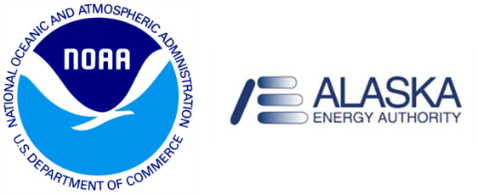

You are cordially invited to attend a Stakeholder meeting to discuss a NOAA National Ocean Service project funded in partnership with the Alaska Energy Authority (AEA) to assess the potential for tidal hydro kinetic energy in Cook Inlet, AK.

NOAA and AEA recently signed a Memorandum of Agreement to complete this project. Over the next few years, NOAA will be measuring and modeling water levels and three-dimensional current, salinity, and temperature fields within Cook Inlet to identify regions with promise for the generation of hydrokinetic energy. NOAA and AEA hope to gather input from stakeholders with interests in hydrokinetic energy in Cook Inlet to compile the needed observations, engineering requirements, and environmental considerations.

What: NOAA/AEA Stakeholder Meeting
When: Wednesday August 24, 2011
Time: 8:30 am – 5:00 pm
Where: Clarion Suites Downtown
1110 W. 8th Avenue
Anchorage, AK
Program
8:30 - Registration and Coffee
8:50 – Welcome, Laura Rear McLaughlin, NOAA
8:55 – Opening Remarks
- Peter Crimp, Alaska Energy Authority
- Representative Paul Seaton, District 35 - Homer
- Kris Holderied, NOAA, Kasitsna Bay Laboratory Director
- Darcy Dugan, Alaska Ocean Observing System
9:30 – Cook Inlet Physical Oceanography
- Sue Saupe, Cook Inlet Regional Advisory Committee
10:00 – Break
10:30 – NOAA Modeling and Observations in Cook Inlet, Rich Patchen and Carl Kammerer
11:00 – Moderated Discussion about Observations and Models
12:00 – Lunch at nearby restaurants
1:30 – Industry Panel and Discussion
- Monty Worthington, Ocean Renewable Power Company
- Walter Dinkins, Baker Hughes
- Jerome Johnson, UAF
- Ben Beste, Alaska Power and Telephone
3:00 – Break
3:30 – Environmental Considerations Panel and Discussion
- Susan Walker, NOAA
- Thomas Eley, Anchorage Waterways Council
- Monte Miller, Alaska Department of Fish and Game
- Manuel Castellote, NOAA, National Marine Mammal Laboratory
- Parker Bradley, University of Alaska Fairbanks
5:00 - Adjourn

