Your Project Name Here

Paste photo(s) here

What was the most important thing you would tell others who are attempting to communicate using either your communication tool (facebook, radio, presentation, etc.) or on your topic?

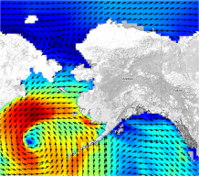
[Your Name]:
[Affiliation]:
[Website]:
[Email]:

2-3 paragraphs of the project you’d like to highlight

Please include:

- What were the key messages, concepts, action items, etc. that you intended to convey
- Who was your target audience(s)
- How did you develop the communication strategy
- What was the strategy (s) you used

[3-5 resources (e.g. links, article names, contact people, etc.) that others should have in hand if they want to employ a similar communication strategy and/or convey messages on a similar topic]

- Resource 1
- Resource 2
- Resource 3
- …

More pictures if you have them…..

