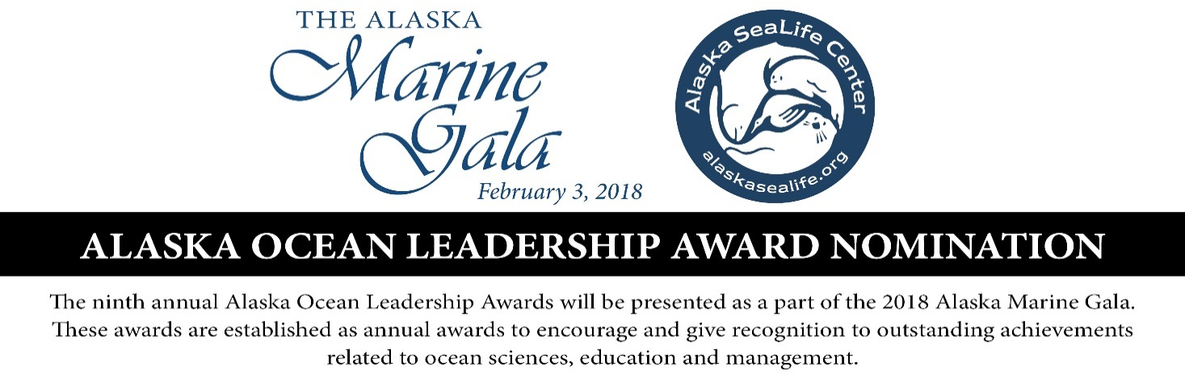
Nomination open through December 1st
Please indicate which award you are nominating for:
Walter J. & Ermalee Hickel’s Lifetime Achievement Award
Stewardship and Sustainability Award
Hoffman-Greene Ocean Youth Award
Marine Research Award
Marine Science Outreach Award

Nominee’s Name:
Title/Organization:
Address:
Phone Number:
Nominee’s E-mail:

Why does this person or institution exemplify the characteristics of this award? (Include work history, achievements and character traits as applicable)
Briefly describe the impact the nominee has made on the marine community:
Nominator’s Name:
Address:
Phone:
E-mail:

Please return this nomination form via e-mail to oceanawards@alaskasealife.org , via fax to
(907) 224-6360 or by mail to Alaska SeaLife Center, P.O. Box 1329, Seward, AK 99664.
For more information, see our web site at www.alaskasealife.org

