Ocean Acidification - Wet Lab

Background:
Since the beginning of the industrial revolution, the release of carbon dioxide (CO₂) from humankind's industrial and agricultural activities has increased the amount of CO₂ in the atmosphere. The ocean absorbs approximately 30-40% of the CO₂ released into the atmosphere every year. As atmospheric CO₂ levels increase, so do the levels of CO₂ in the ocean. Dissolving CO₂ in seawater increases the hydrogen ion (H+) concentration, decreases ocean pH, making seawater more acidic. Since the industrial revolution surface ocean pH is estimated to have decreased from approximately 8.2 to 8.1, representing an increase of almost 35% in H⁺ ion concentration in the world's oceans. Computer models predict that the ocean will become 150% more acidic by 2100.

Source for text: http://en.wikipedia.org/wiki/Ocean_acidification
and https://www.pmel.noaa.gov/co2/story/What+is+Ocean+Acidification%3F

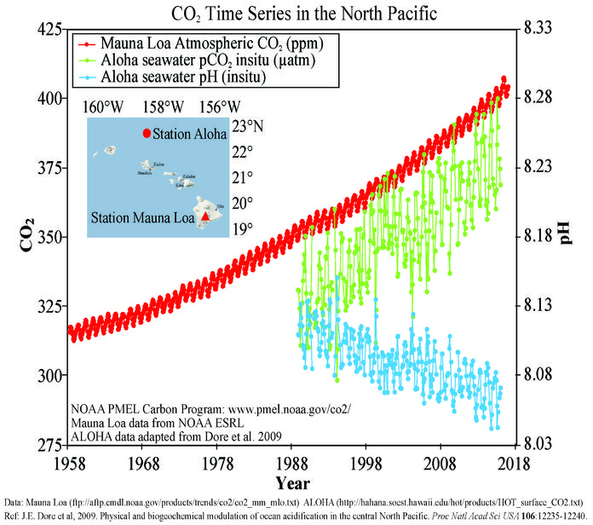

Procedure:
- Make sure that at your lab station all of the following:
  - vacume filtration flask with hose attached
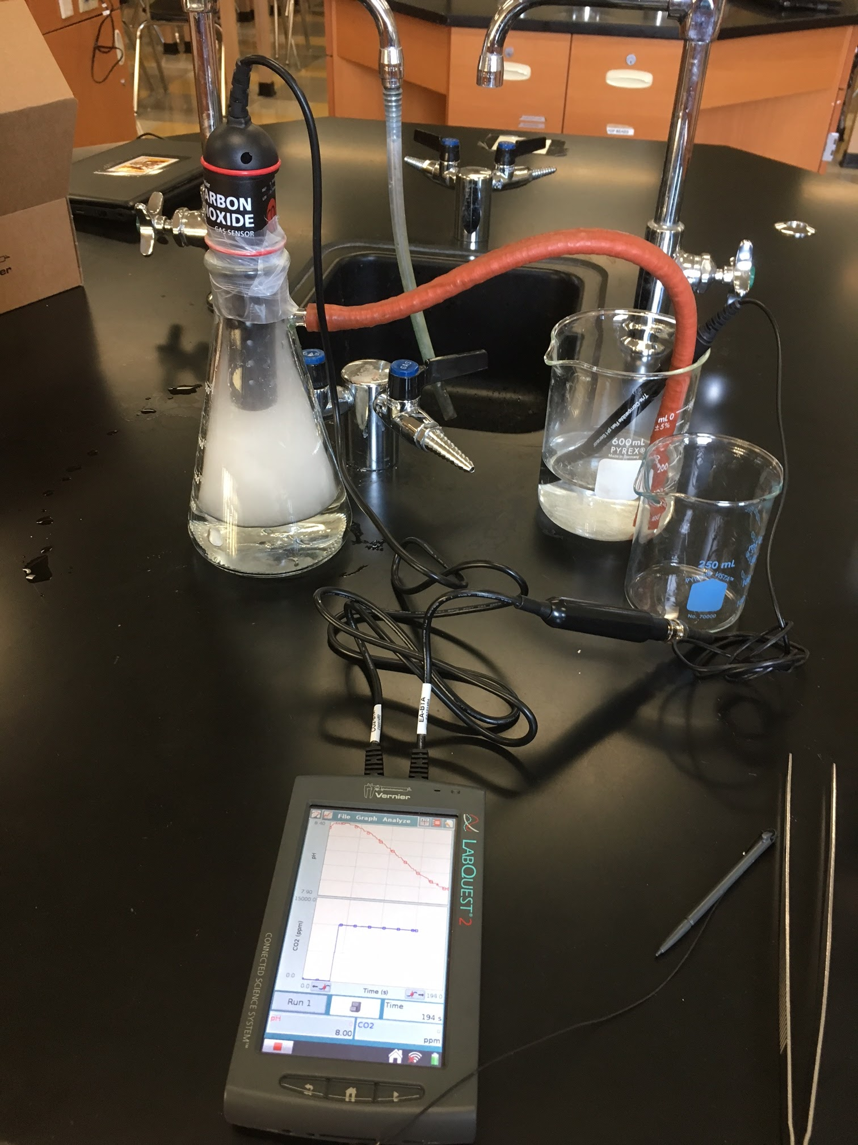
  - 400 or 600 ml beaker
  - 1 one 3cm strip of parafin
  - pH probe, CO₂ probe, and lab quest (or computer)
- Fill your beakers with 200 ml of sea water.
- Turn on your labquest and plug in the CO₂ probe, and the pH probe in channels 1 and 2 of the labquest.
- Ajust the time settings on the labquest to 600 seconds (10 min), you can keep the sampling rate at the default.
- Carefully twist off the white pH probe cover and set it aside in a safe place. Submerge the active end of the pH probe into the medium size beaker with sea water.
- Pour 200 ml of tap water into the filtration flask.
- At this point you should be ready ask your teacher for a piece of dry ice (solid CO₂). Safety note: dry ice can burn the skin, it should never be touched. Allow your teacher to place a small piece into your flash using metal tongs.
- Stick the tip of the CO₂ probe into the top of the filtration flask. Make sure the probe tip does not touch the water or get wet. Stretch the paraffin and wrap the CO₂ probe to create an airtight seal.
- Push the green start button on the labquest. Your setup should look like the picture above. You should take note of the initial readings on the pH and CO₂ probes.

Results:
- What do you predict will happen to the level of CO₂ in the flask as the dry ice begins to sublimate (turn from a solid into gas?)

- CO₂ dissolves easily in water. What do you predict will happen to the pH of the water when CO₂ is pumped in?

- Please fill in the initial readings for the pH and CO₂ probes.
pH CO₂

- Please fill in the final readings for the pH and CO₂ probes.
pH CO₂

- Make a sketch of the graphs produced by each probe. Be sure to label the axis.
pH | CO₂

Analysis Questions:
- After running the experiment, what did the results show you. What was the relationship between CO₂ and pH? What does adding carbon dioxide to sea water do to the pH of seawater?

- Examine the graph on the front page of this lab. What has happened to the amount of CO₂ measured at the top of Mona since 1958? What has happened to the ocean pH at station Aloha since they began taking measurements in 1988? For both, please cite specific numbers.

